# Homework: HTML5 Forms

## Simple Form

Create a HTML form like the image below (100% accuracy is not required). Put appropriate validation and placeholders.

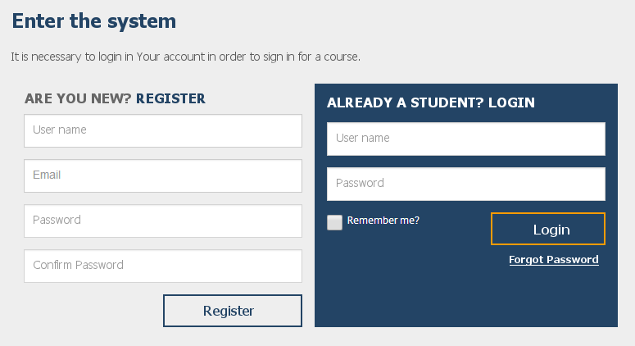

## Flight Order

Create a HTML page like the image below (100% accuracy is not required).

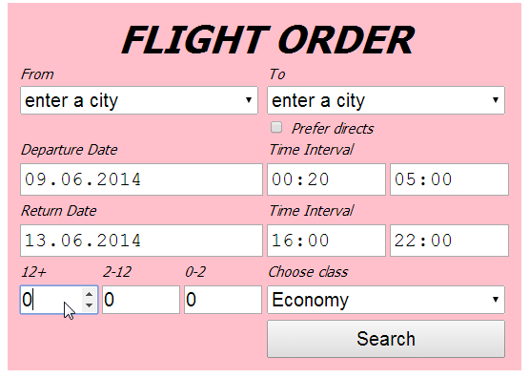

## WordPress Theme

Create a HTML page like the image below (100% accuracy is not required).



## Fakebook Register Form

Create a HTML page like the image below (100% accuracy is not required). Make the fields on the right required. Use field validation for email and phone number. Set some tab indexes. Use labels where possible.

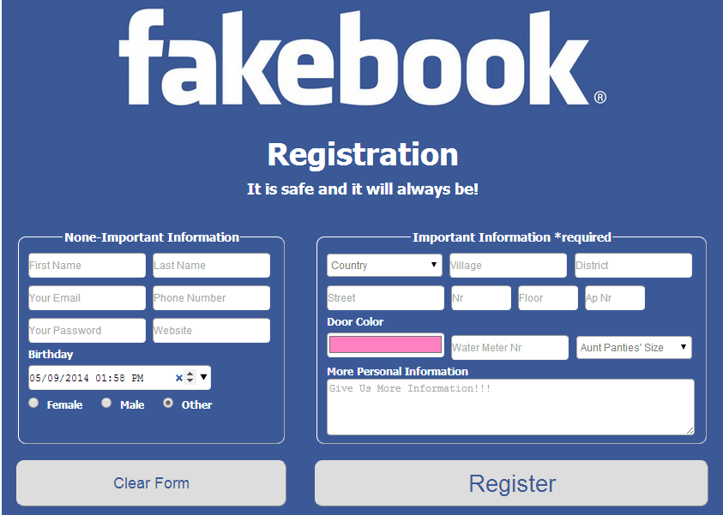

## Laptop Choice

Create a HTML page like the image below (100% accuracy is not required). You don’t need to optimize the sliders for all browsers. Each group of elements, marked in red, must be a button that opens a link by choice. *The red rectangle is not a part of the assignment.*

